|  |  |  |
| --- | --- | --- |
| *Application connection time to* | | |
| Trials | **Post Reservation**  **(177 Bytes)** | **Get Reservation**  **(177 Bytes)** |
| 1 | 0.011711 s | 0.007428 s |
| 2 | 0.011810 s | 0.007435 s |
| 3 | 0.011822 s | 0.007423 s |
| 4 | 0.011734 s | 0.007430 s |
| Average | **0.011777 s** | **0.007429 s** |

|  |  |  |
| --- | --- | --- |
| *Application connection time to* | | |
| Trials | **Post Currently Looking**  **(52 Bytes)** | **Get Currently Looking**  **(52 Bytes)** |
| 1 | 0.012628 s | 0.007298 s |
| 2 | 0.012623 s | 0.007295 s |
| 3 | 0.012625 s | 0.007294 s |
| 4 | 0.012630 s | 0.007299 s |
| Average | **0.012627 s** | **0.007296 s** |

|  |  |  |
| --- | --- | --- |
| *Application connection time to* | | |
| Trials | **Post User**  **(113 Bytes)** | **Get User**  **(113 Bytes)** |
| 1 | 0.012106 s | 0.007584 s |
| 2 | 0.012110 s | 0.007590 s |
| 3 | 0.012109 s | 0.007588 s |
| 4 | 0.012115 s | 0.007583 s |
| Average | **0.012112 s** | **0.007586 s** |

|  |  |  |
| --- | --- | --- |
| *Application connection time to* | | |
| Trials | **Post Zone**  **(8606 Bytes)** | **Get Zone**  **(8606 Bytes)** |
| 1 | 0.017234 s | 0.008668 s |
| 2 | 0.017236 s | 0.008664 s |
| 3 | 0.017239 s | 0.008663 s |
| 4 | 0.017235 s | 0.008666 s |
| Average | **0.017236 s** | **0.008666 s** |

|  |  |  |
| --- | --- | --- |
| *Application connection time to* | | |
| Trials | **Post Spot**  **(49 Bytes)** | **Get Spot**  **(49 Bytes)** |
| 1 | 0.011525 s | 0.007122 s |
| 2 | 0.011524 s | 0.007121 s |
| 3 | 0.011526 s | 0.007120 s |
| 4 | 0.011528 s | 0.007124 s |
| Average | **0.011526 s** | **0.007123 s** |

|  |  |  |
| --- | --- | --- |
| *Application Average Connection Time to* | | |
|  | **Post** | **Get** |
| Reservation (177 bytes) | 0.011777 s | 0.007429 s |
| Currently Looking (52 bytes) | 0.012627 s | 0.007296 s |
| User (113 bytes) | 0.012112 s | 0.007586 s |
| Zone (8606 bytes) | 0.017236 s | 0.007666 s |
| Spot (49 bytes) | 0.011526 s | 0.007123 s |

To test internet connection to and from Application and Firebase in several data sizes.

In general, we observed that reading data from firebase database is more faster than posting data in the firebase regardless to the number of bytes which is good as our system should be in real time which mean that any changes in the data will be fetched and reflected to the UI very quickly.

Algorithm for measuring time

Step 1: read system time and store it in a variable called startTime

Step 2: write code for reading from database

Step 3: read system time again and store it in variable called endTime

Step 4: subtract the startTime from endTime and display result in the console

Post reservation

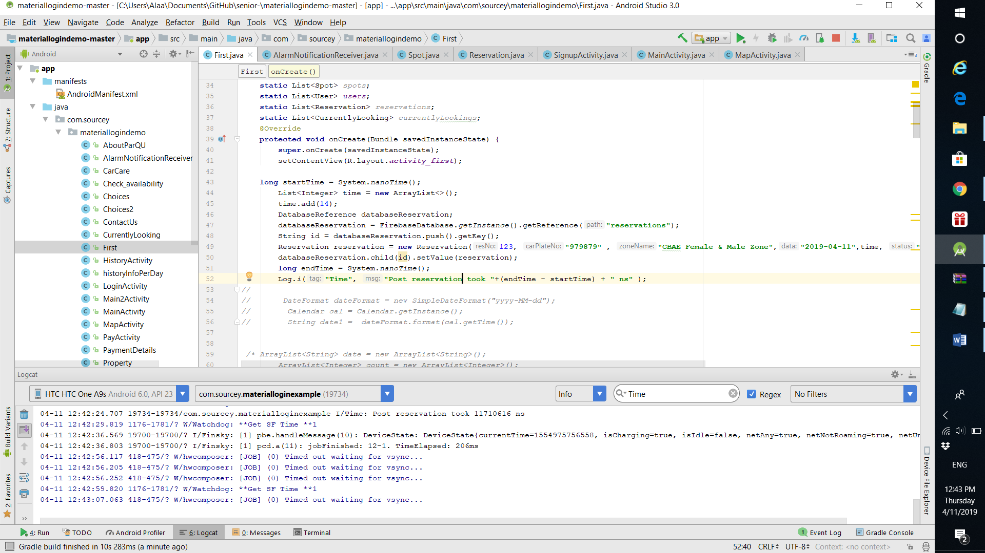

Read reservation

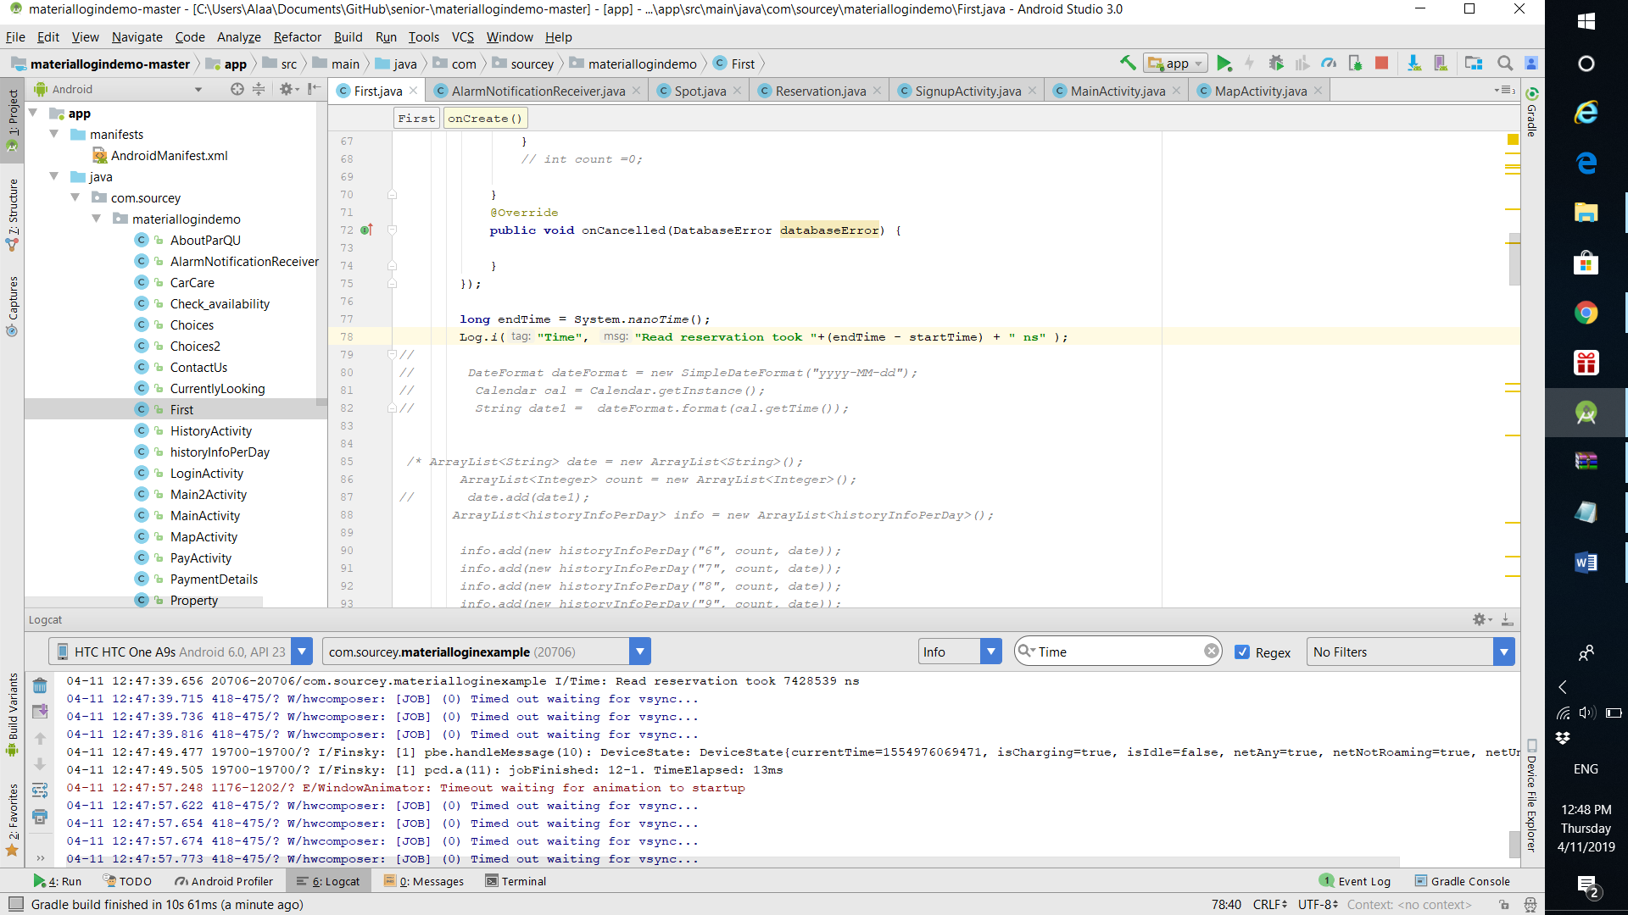

Delete

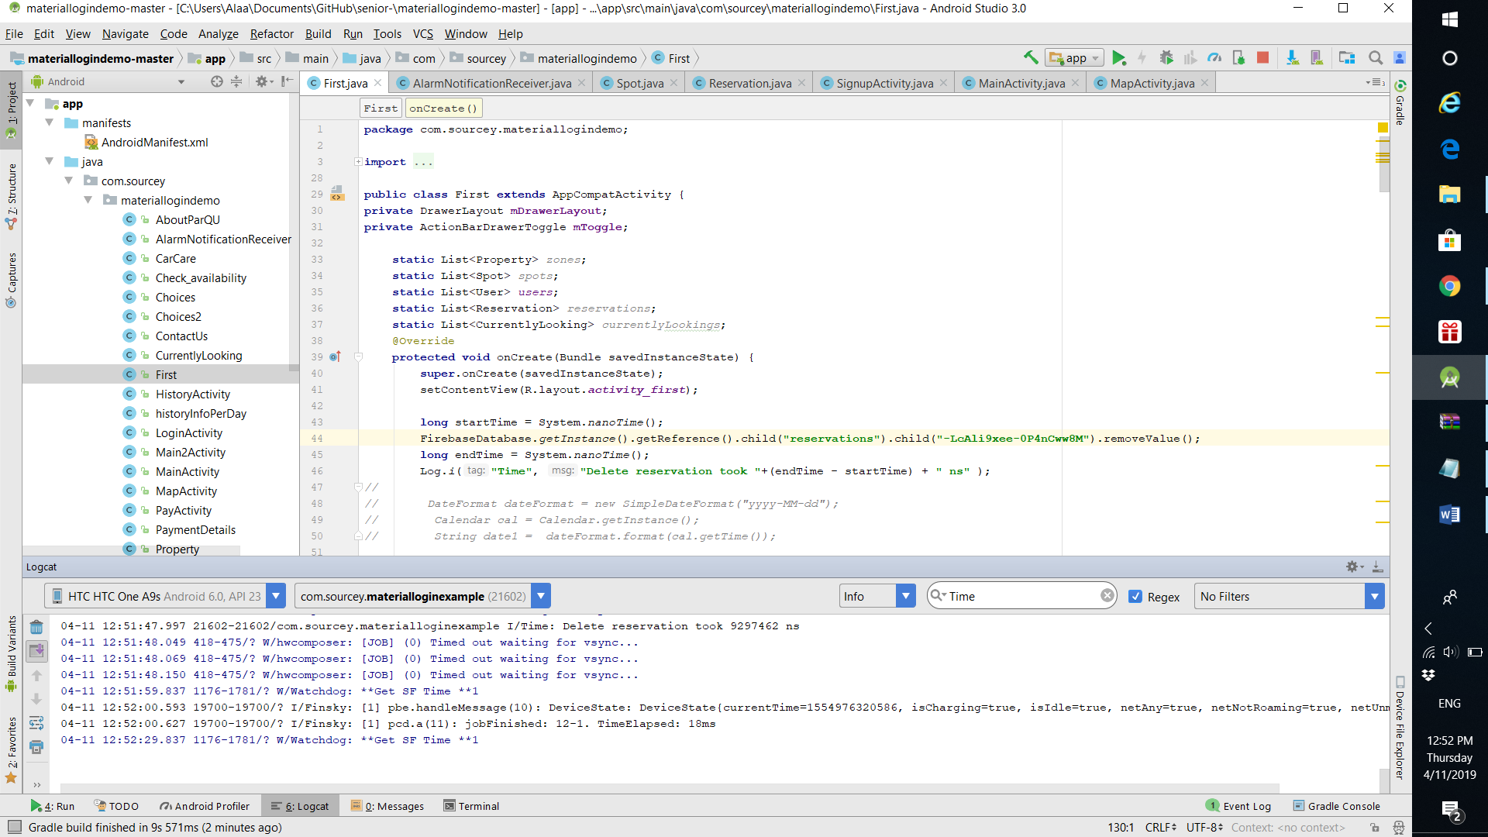

Add user

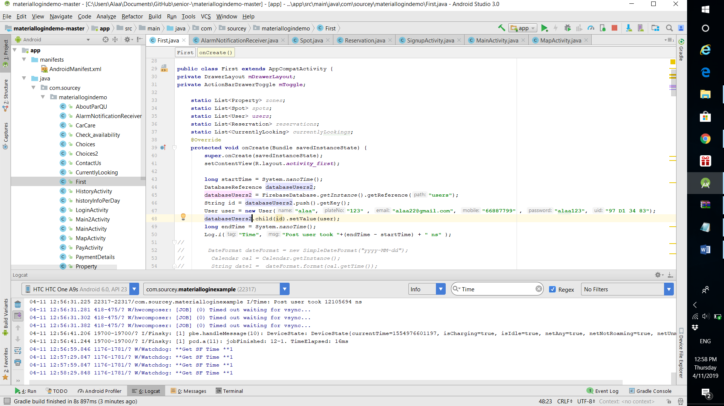

Get user

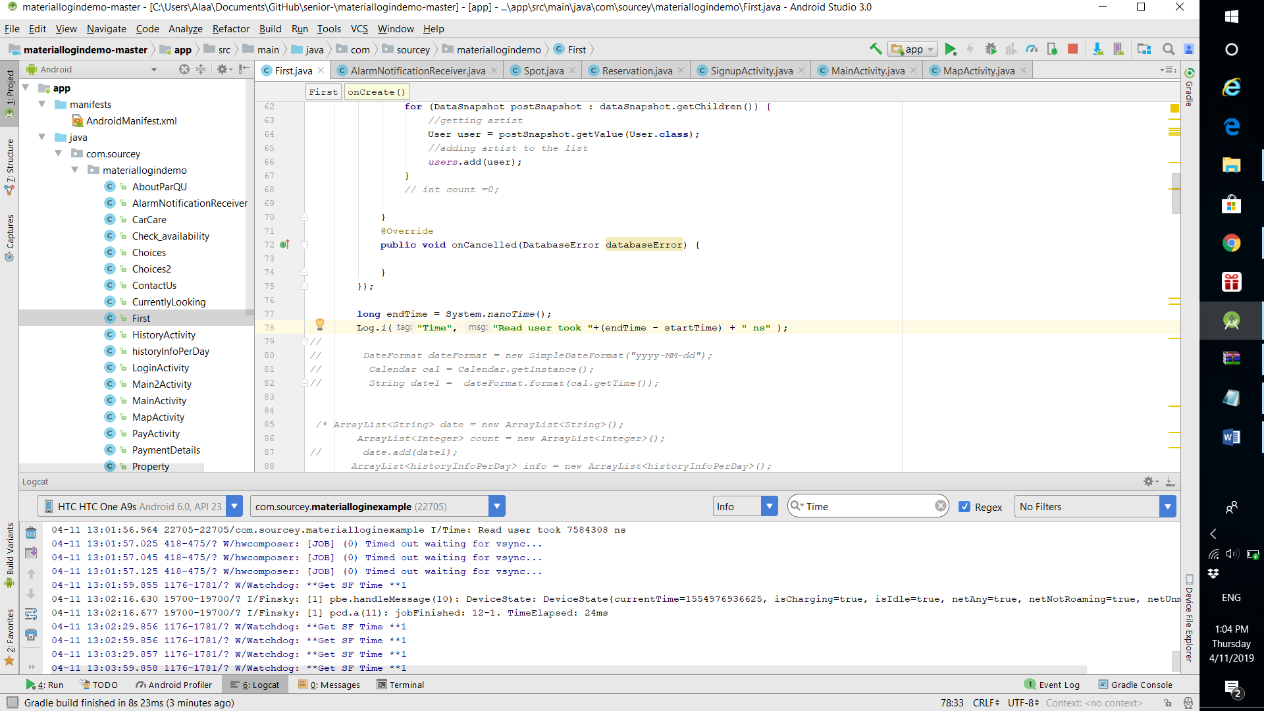

Add curre

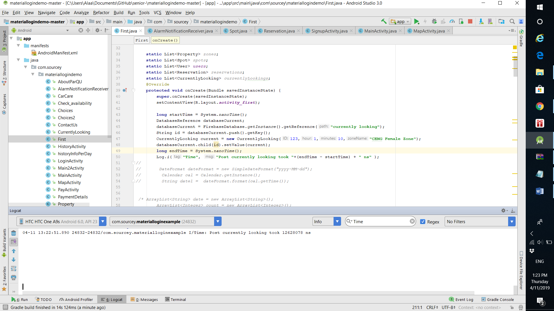

Delete current

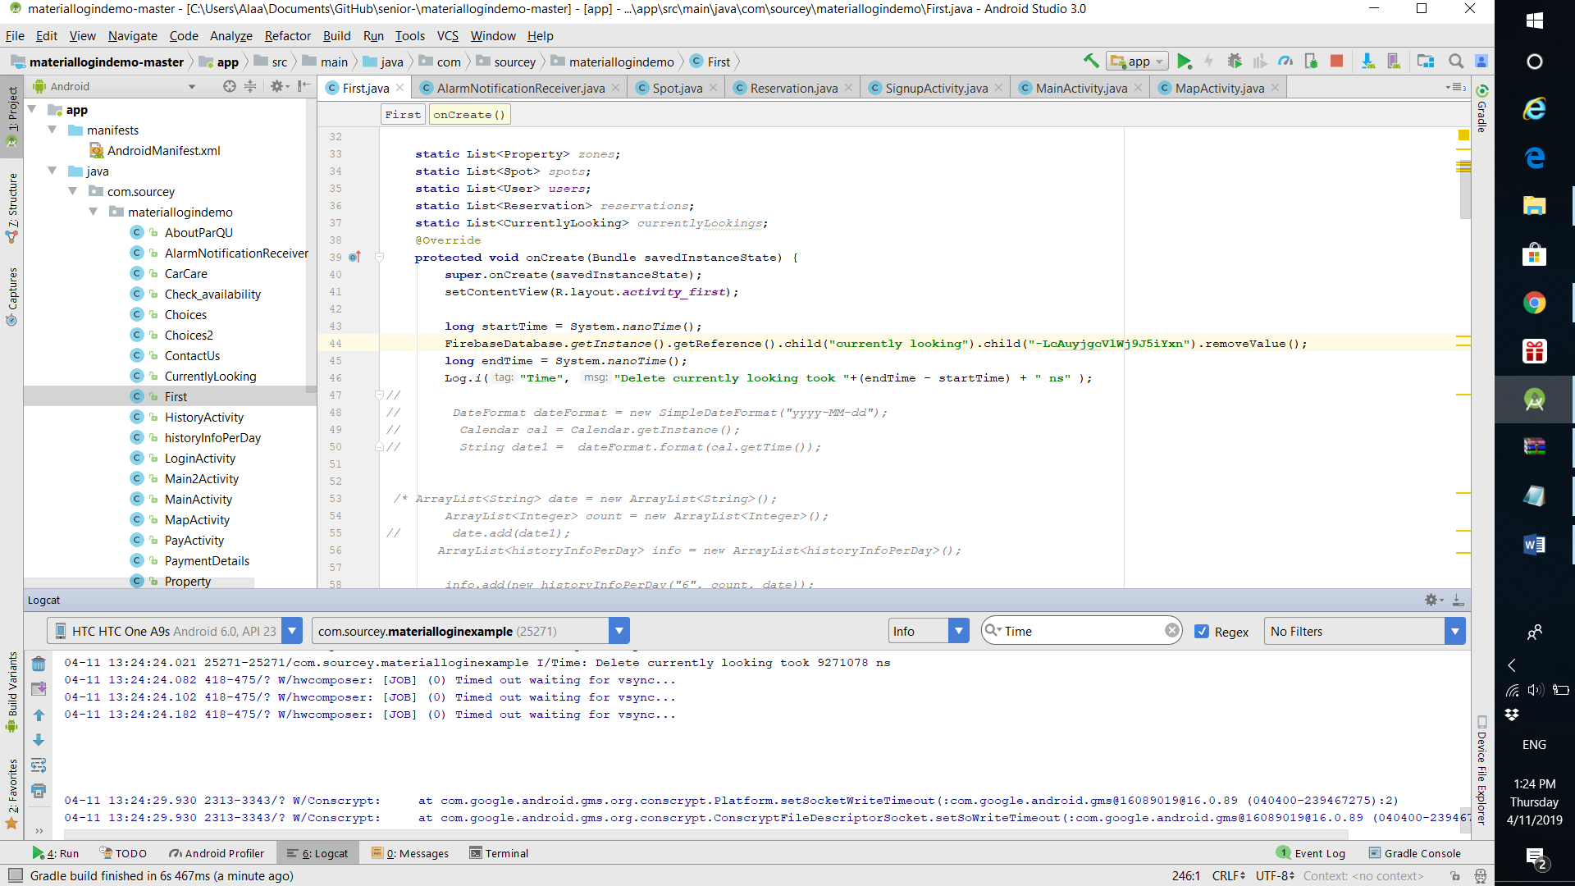

Get

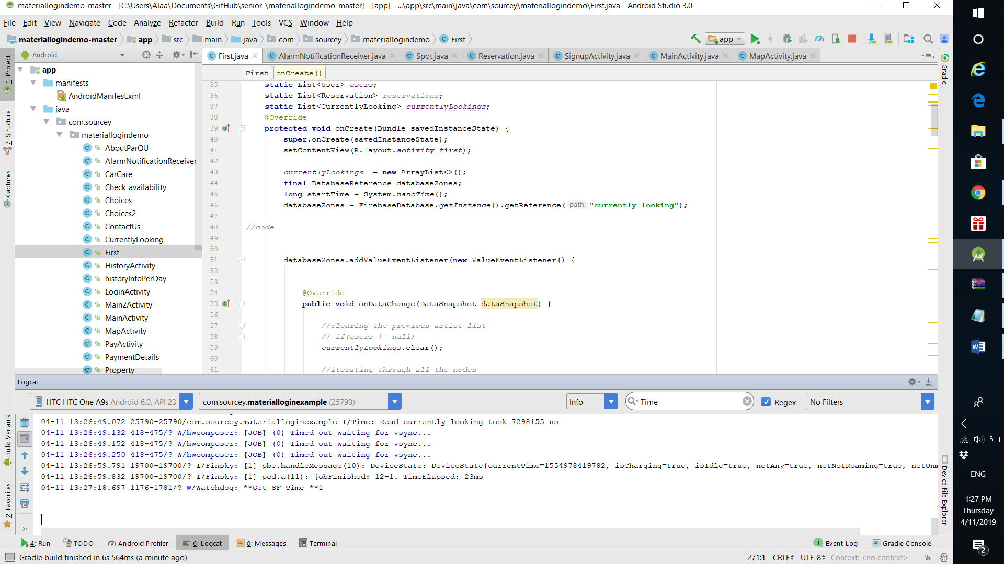

Get zones

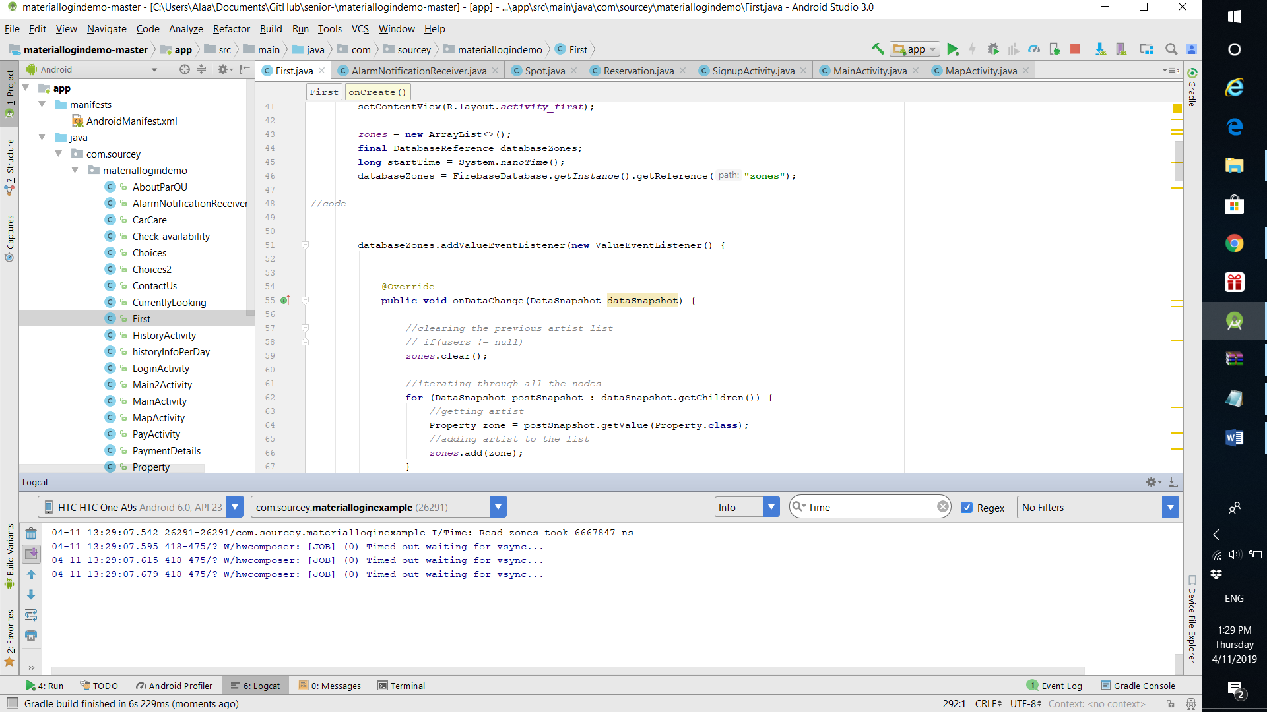

Post zone

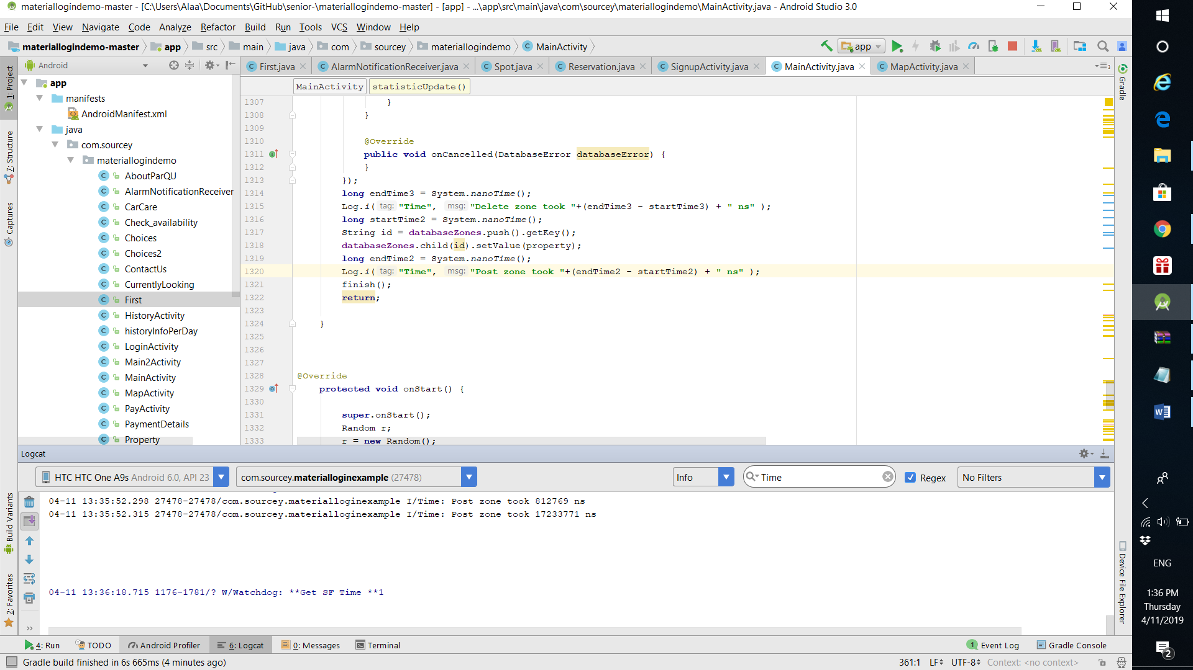

Get spots

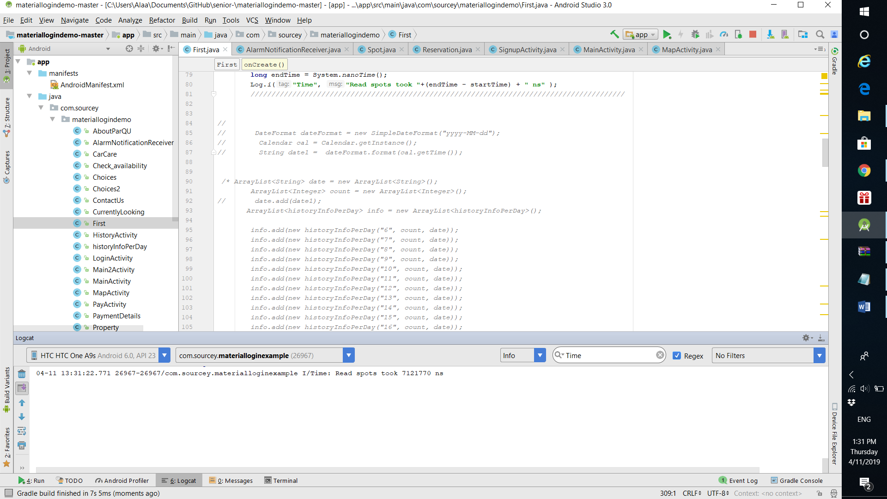

Post spot

